### 1. Complete Self Learn Videos (Section-3, Lesson-1 and Lesson-2) before next Saturday [ very important]

Done

### 2. Write the concepts discussed about strings in class List down Data Types in Java (with wrapper class name, memory size, range) in a tabular format.

|  |  |  |  |  |  |
| --- | --- | --- | --- | --- | --- |
| **Primitive Data Type** | **Wrapper Class** | **Memory Size (byte)** | **Min Range** | **Max Range** | **Comment** |
| byte | Byte | 1 | -128 | 127 |  |
| short | Short | 2 | -32768 | 32767 |  |
| int | Integer | 4 | -2147483648 | 2147483647 |  |
| long | Long | 8 | -9.22337E+18 | 9.22337E+18 |  |
| float | Float | 4 | 4.00E-45 | 4.03E+44 |  |
| double | Double | 8 | 9E-324 | 7976931348623157E308 |  |
|  |  |  |  |  |  |
| char | Character | 2 | - | - |  |
| boolean | Boolean | - | - | - | True or False |
| **Non- Primitive Data Type** |  |  |  |  |  |
| string | String | 2bytes/character | - | - |  |

### 3. Write examples for increment and decrement operators

Refer to examples in .java file in git hub repository.

### 4. Write java code for below programs:

### a. Factorial of a number

### b. Multiplication table of a given number

### c. nCr and nPr values

Refer to examples in .java file in git hub repository.

## 5. Write the concepts discussed about strings in class

A string is a type of variable used to store a sequence of characters. It takes up 2bytes of memory per character. A string is immutable, meaning it’s memory allocation cannot be changed but recreated in heap memory unlike all other primitive data types. When the same string variable is changed, the original allocated memory will refer to the new location of the variable in heap memory. Garbage collector tool may remove the original string variable which has been edited and free heap memory for new use.

## 6. Research and write what is String pool in java

String pool is a storage area in [heap memory,](https://www.javatpoint.com/java-heap) where string literals stores. It is synonymous with String Intern Pool or String Constant Pool maintained by the [Java String](https://www.javatpoint.com/java-string) class. Whenever we create a string the string object occupies some space in the heap memory. Creating a number of strings may increase the cost and memory too which may reduce the performance so To decrease the number of String objects created in the JVM the String class keeps a pool of strings. When we create a string literal, the JVM first check that literal in the String pool. If the literal is already present in the pool, it returns a reference to the pooled instance. If the literal is not present in the pool, a new String object takes place in the String pool.

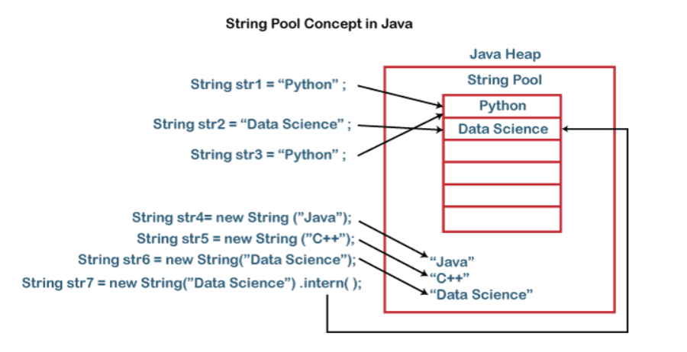

## 7. Write Java code to read number from user and print multiplication table of the number.

Refer to examples in .java file in git hub repository

## 8.Reaserch and write about which is faster, Java or Python ?

Java is generally faster and more efficient than Python because it is a compiled language. As an interpreted language, Python has simpler, more concise syntax than Java. It can perform the same function as Java in fewer lines of code. Java’s efficiency largely comes from its Just-In-Time (JIT) compiler and support for concurrency. The JIT compiler is a part of the Java Runtime Environment. It improves performance of Java programs by compiling bytecodes into native machine code “just in time” to run. Java Virtual Machine (JVM) calls the compiled code directly. Since the code is not interpreted, compiling does not require processor time and memory usage. Theoretically, this can make a Java program as fast as a native application. While Java programs are compiled directly, Python is interpreted which slows down Python programs during runtime. Determining the variable type which occurs during runtime increases the workload of the interpreter. Also, remembering the object type of objects retrieved from container objects contributes to memory usage.

In Python, any bugs introduced by the programmer will not be found until that line of code is triggered. This can risk operational breakdowns and extend turnaround time. While Python leaves objects vulnerable to mutation, in Java object mutations is impossible. This leads to secure software development.